SOCIAL STATISTICS
SOC 24100

Exam #1

Name _________________ Date _________________

You are currently interning at the Stone Center on Socio-Economic Inequality, CUNY, and your mentor has asked you to prepare a report on gender inequality on the U.S. labor market. Since you are still relatively unfamiliar with the data, they have kindly provided you with the following material:

- 1 outline for your research report
- 1 project summary
- 6 variable descriptions
- 2 raw data tables
- 2 frequency distribution tables
- 2 percentage distribution tables
- 2 graphs
- 1 bivariate table

As you write your report, feel free to use one or more pieces of information to slowly build your analysis.

Formulas you might need:

1. Mean
$\overline{χ}$=
$$S_{y}^{2}=\frac{\sum{{\left(Y-\overline{Y}\right)}^{2}}}{N-1}$$
2. Variance

$$S_{Y}=\sqrt{\frac{\sum{{\left(Y-\overline{Y}\right)}^{2}}}{N-1}}$$

3. Standard Deviation

            - Research Report Outline
- Introduction

A good introduction summarizes a study’s research question, the research hypothesis under investigation, the variables used for the analysis, as well as the key findings. Let’s begin with the first three components (hint: you might want to take a quick glance at the project summary):

  - What is the main question your research report is trying to answer? (2 points)

  - What was the researchers’ hypothesis, i.e. what did the researchers at the Stone Center expect to find? (2 points)

  - What were the two main variables under investigation? (2 points)

  - Which one was the independent, which one the dependent variable? (2 points)

- Methodology

Methods sections typically begin with a detailed description of all variables included in the analysis, particularly their level of measurement. To connect your Methodology with your Descriptive Statistics section, you should not forget to include some descriptive tables (hint: how about taking a look at the variable descriptions?):

  - What is the level of measurement of all variables included in the analysis? (2 points each)

Age of respondent:

Annual income:

Labor force status:

Race:

Gender:

Years of education:

  - For your independent and dependent variable only: Construct a percentage distribution table, taking the frequency distribution tables as a starting point. Include cumulative percentages if appropriate. (hint: you could simply add extra columns to the frequency distribution tables)
(15 points)

- Descriptive Statistics

Descriptive statistics sections summarize the distribution of responses for each variable with the help of measures of central tendency, measures of variability, and graphs. They are the foundation of any analysis that follows.

  - Measures of Central Tendency
    - For all variables included in the analysis, obtain all appropriate measures of central tendency, either by calculating them from the raw data or by drawing on the percentage distribution tables. For calculations, please provide notes on all steps to receive full credit.
(9 points)

 | Mode | Median | Mean
Age of respondent
Annual income
Labor force status
Race
Gender
Years of education

    - Include a brief interpretation for each variable, describing what the measures of central tendency tell you about that variable. (6 points)

    - Looking just at the education variable: Which measure of central tendency would you report to best describe what is average about the variable? Why? (3 points)

  - Measures of variability
    - For all variables included in the analysis, obtain all appropriate measures of variability by calculating them with the help of the raw data or by drawing on the frequency tables. For calculations, please provide notes on all steps. (12 points)

 | Range | IQR | Variance | Standard Deviation
Age of respondent
Annual income
Labor force status
Race
Gender
Years of education

    - Include a brief interpretation for each variable, describing what the measures of variability tell you about that variable. (6 points)

    - Looks like your mentor left you another piece of information. Take a look at this descriptive table from comparative income data gathered in the U.S. and Iceland. Could you do your mentor a small favor and let them know whether based on this information, women, on average, should choose to work in the U.S. or in Iceland? Why would you say so? (5 points)

 | U.S. | Iceland
Mean | $72,100 | $70,000
Median | $42,000 | $65,000
Standard Deviation | $17.80 | $5.27

  - Graphs
    - Graphs are a great way to visualize the distribution of your variables. For all variables included in the analysis, make a note which type of graphs could be used to visualize them. (6 points)

Age of respondent:

Annual income:

Labor force status:

Race:

Gender:

Years of education:

    - Take a look at the two graphs included in your material. Based on these two graphs, which of the two variables has the greater variability? How do you know? (4 points)

- Findings

Findings sections represent the core of every research report and should include the statistical analysis and interpretation of the data.

  - Since we did not get around to running any statistical analyses yet, take a look at the bivariate table and describe the relationship between the two variables. Do you think a relationship exists? Why? (4 points)

  - How would you know whether the two variables are causally related, i.e. what are the prerequisites for proving causality? (3 points)

- Conclusion

Conclusions summarize the key findings, discuss any limitations of the research presented, and give an outlook of what needs to be done in the future. (3 points)

  - The analysis presented in this report is pretty detailed, but no analysis is perfect. Go to the General Social Survey website at https://gssdataexplorer.norc.org/variables/vfilter and pick 3 more variables that could help explain differences in income. Alternatively, you can think of 3 variables yourself, including question and potential answer choices.

  - Your mentor at the Stone Center has indicated that they are unhappy with the way income is measured in the dataset and has asked you to include alternative ways to measure it, so future research can draw on your advice. Construct both an interval-ratio and a dichotomous income variable. (4 points)

            - Project Summary

Even as many countries, including the U.S., have taken steps to mitigate gender inequality, the gender pay gap – a measure of gendered income inequality – has remained alarmingly stable. Drawing on 2018 data from the General Social Survey (GSS), this project set out to asses just how large the gender pay gap currently is in the U.S. As anticipated, American women, on average, earned less annual income than men, controlling for race, labor force status, years of education, and age. The findings of this project show that future research also needs to investigate what other factors may contribute to the persisting gender pay gap, and how these factors may affect some women’s income more than others.

            - Variable Descriptions
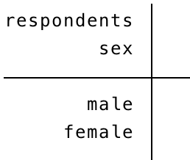
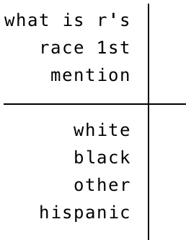
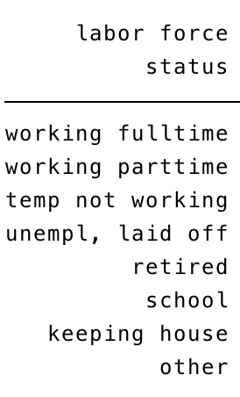
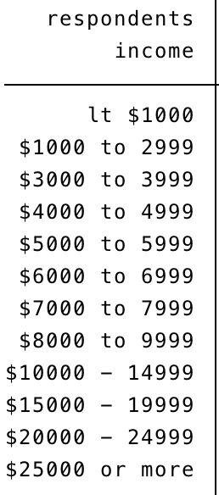
- Race
- Years of education (in years)
- Gender
- Labor force status
- Annual income
- Age of respondent (in years)

Respondent ID | Age
#1 | 44
#2 | 18
#3 | 53
#4 | 44
#5 | 39
#6 | 36
#7 | 22
#8 | 50
#9 | 65
#10 | 73
            - Raw Data Tables

Respondent ID | Highest year of schooling
#1 | 16
#2 | 3
#3 | 12
#4 | 13
#5 | 15
#6 | 16
#7 | 12
#8 | 20
#9 | 16
#10 | 20

            - Frequency Distribution Tables

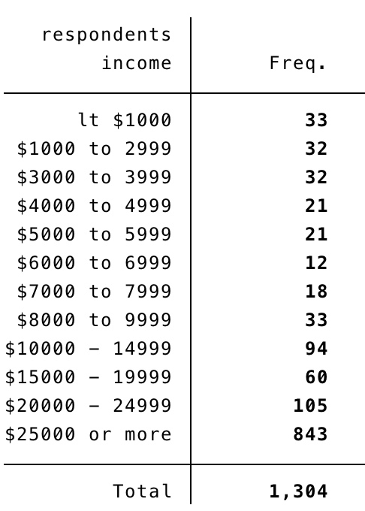

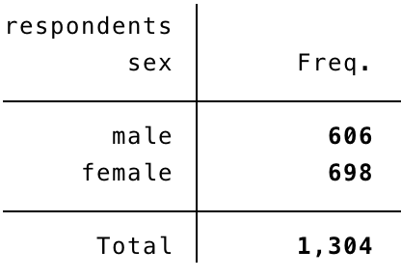
            - Percentage Distribution Tables

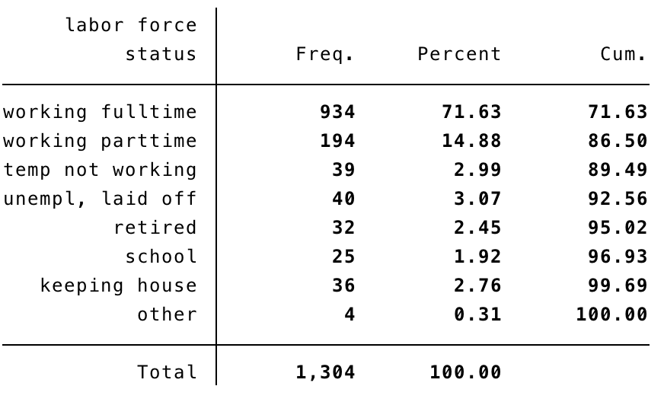
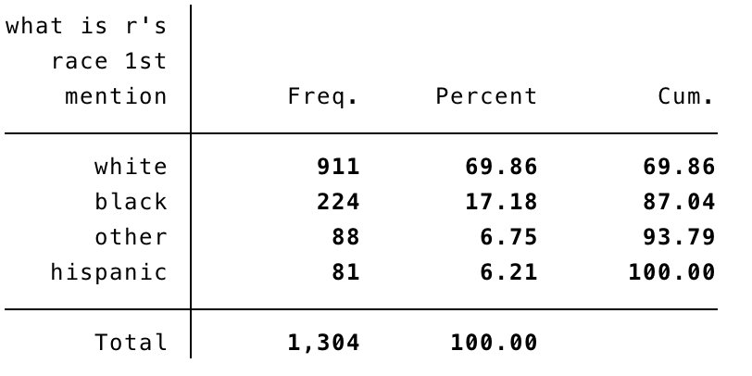
            - Graphs

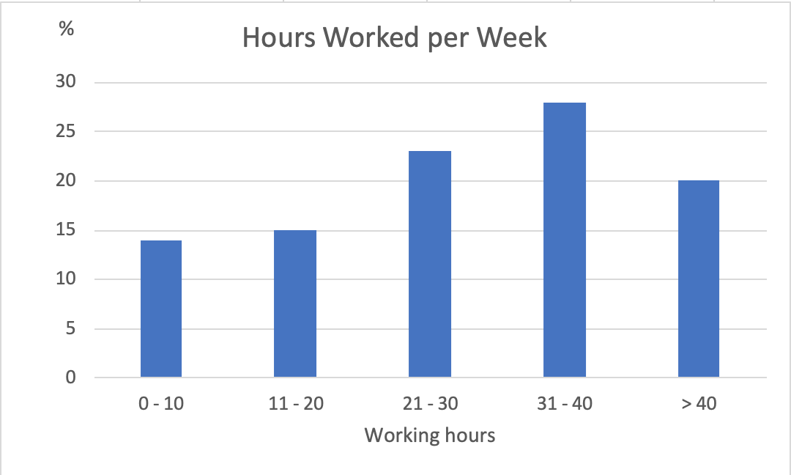

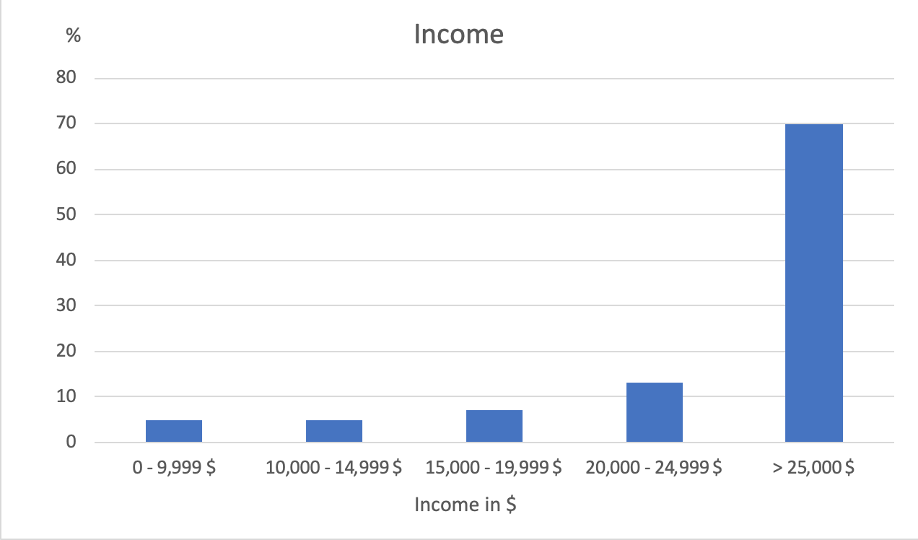
            - Bivariate Table

Table 1: Respondent’s income by gender

Respondent’s income | Male (in %) | Female (in %) | Total (in %)
Less than $1000 | 2.31 | 2.72 | 2.53
$1000 to $2999 | 1.49 | 3.30 | 2.45
$3000 to $3999 | 1.49 | 3.30 | 2.45
$4000 to $4999 | 1.65 | 1.58 | 1.61
$5000 to $5999 | 1.32 | 1.86 | 1.61
$6000 to $6999 | 0.17 | 1.58 | 0.92
$7000 to $7999 | 0.99 | 1.72 | 1.38
$8000 to $9999 | 1.98 | 3.01 | 2.53
$10,000 to $14,999 | 4.95 | 9.17 | 7.71
$15,000 to $19,999 | 2.97 | 6.02 | 4.60
$20,000 to $24,999 | 7.59 | 8.45 | 8.05
$25,000 or more | 73.10 | 57.31 | 64.65
Total | 100.00 | 100.000 | 100.00

